Radon Potential Map Changes
All information below is from https://www.ukradon.org/
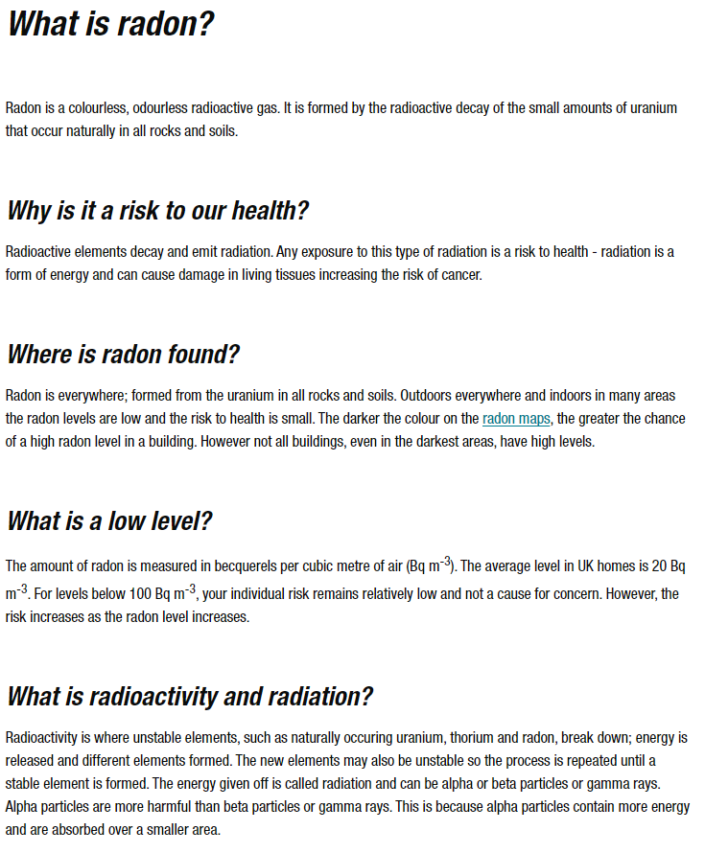

UK maps of radon
Radon information
UKHSA has published reports containing radon Affected Area maps for the whole of the United Kingdom. Copies of the reports are available in resources.
UKHSA launched the new radon map on 01/12/22 - some users have experienced issues due to the cached data on their web browser. If you clear your history for cached data and images and re-visit the website this should load. You can view the press release regarding the new radon map data https://www.ukradon.org/information/ukmaps
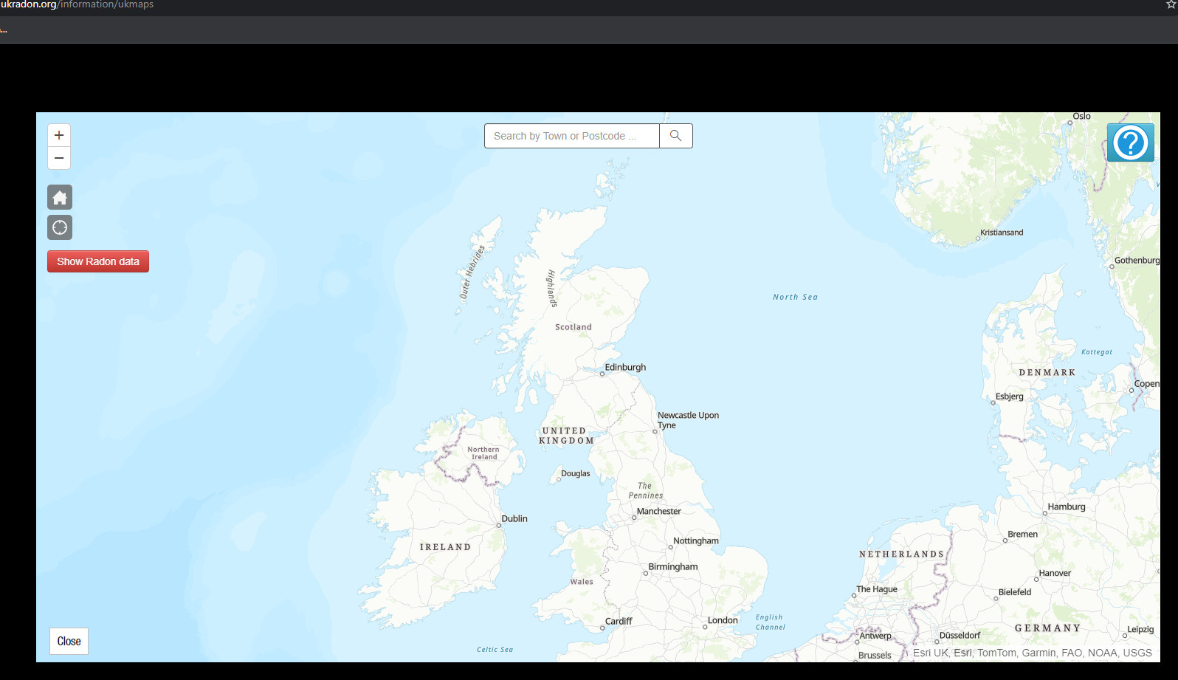
Use the zoom tools in the top left corner or scroll your mouse to the area you live
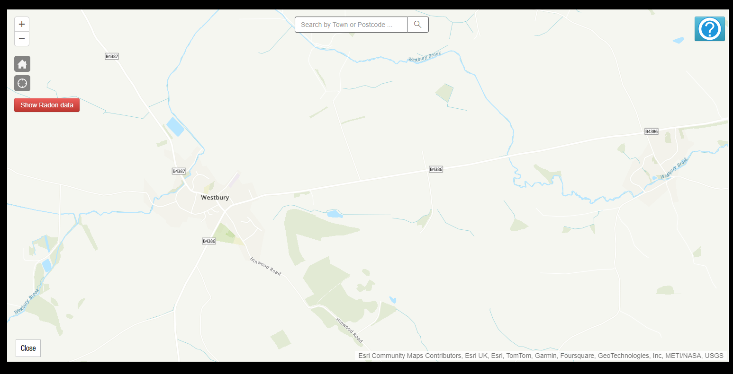

Click the red button to ‘Show Radon Data’.

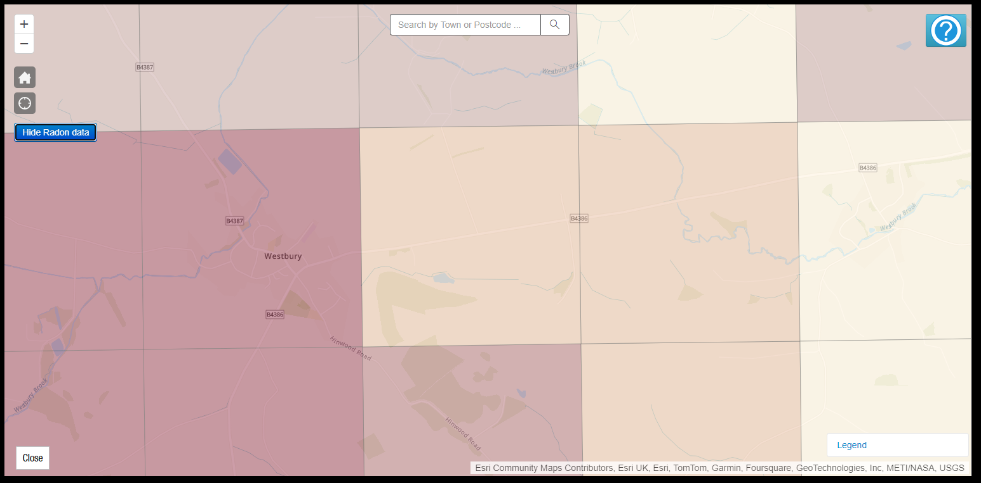
Coloured squares will appear on the map. To show the key for the map click the ‘Legend’ button in the bottom right corner of the screen.

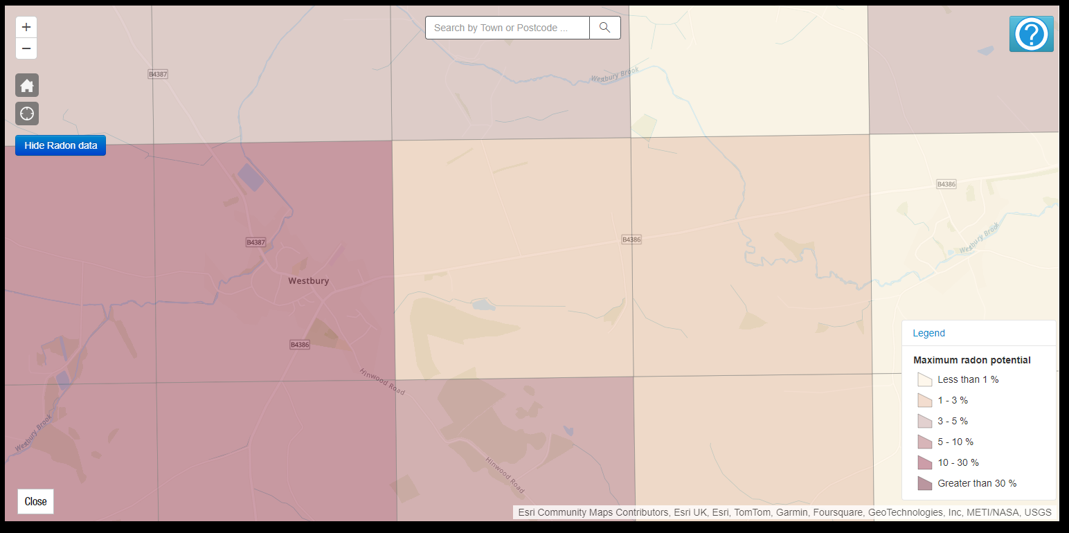
The legend will show the ‘Maximum radon potential’ as a percentage on the coloured key.
This is the percentage of properties likely to be affected by Radon Gas.
Order a home test kit. Information is available in the link below on how this works and the cost of the test.

https://www.ukradon.org/services/orderdomestic

UKHSA will post you two detectors to place in your home: one in the living area and one in an occupied bedroom. After three months you post the detectors back to us in the pre-paid envelope provided. We analyse the detectors and post the results to you: the cost is £52.80 inc. VAT.

The detectors
Radon detectors are safe and simple to use: e.g., they can sit on a shelf. The hollow plastic shell contains a piece of clear plastic that records the damage caused by radon. The detectors do not emit anything and do not collect anything dangerous. However, they can be damaged by heat or submersion in water and should not be opened.
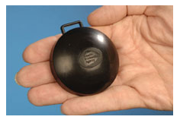

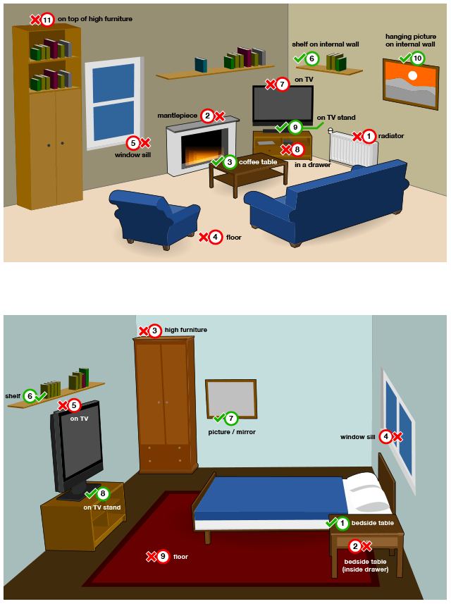

What is the Action Level?
UK Health Security Agency recommends that radon levels should be reduced in homes where the average is more than 200 becquerels per metre cubed (200 Bq m⁻³). This recommendation has been endorsed by the Government.
This Action Level refers to the annual average concentration in a home, so radon measurements are carried out with two detectors (in a bedroom and living room) over three months, to average out short-term fluctuations.
If your result is at or above the UK Action Level of 200 Bq m⁻³, see our information on reducing radon. Sometimes a free re-measurement is available to check the remedial work.

UKHSA will send you your results and further guidance for reducing radon levels is available on their website. Retesting is available following remedial works if your property is above the action level.
https://www.ukradon.org/information/reducelevels

