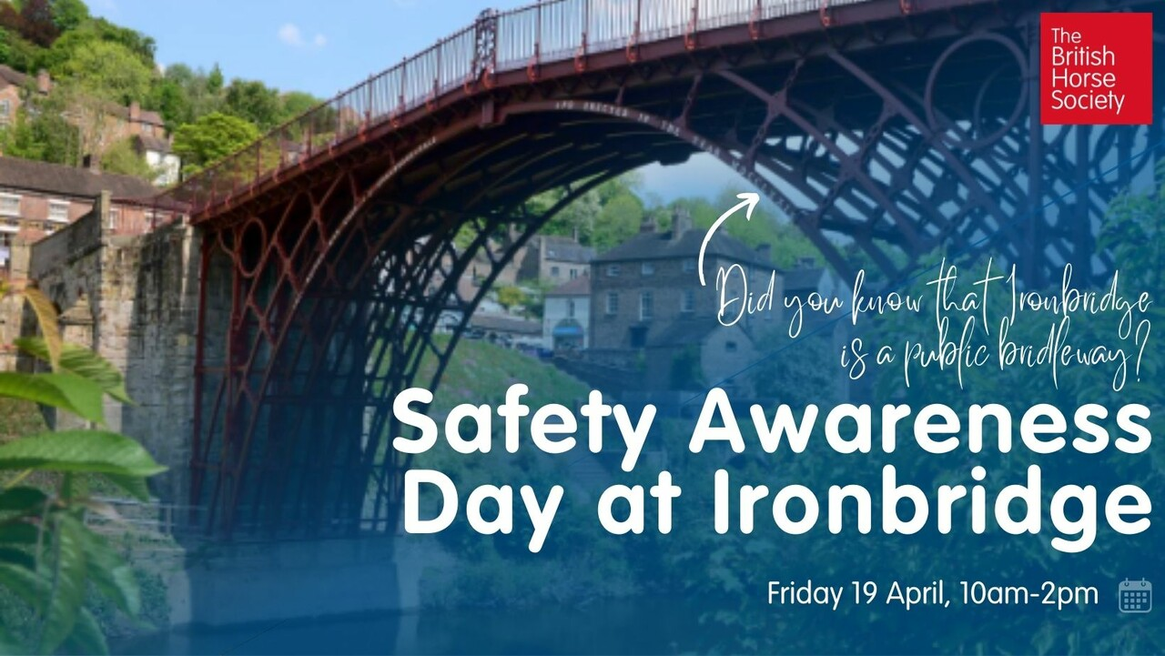
By kind permission of Telford and Wrekin Council

Station Yard Car Park, Ironbridge, TF8 7JP - 10am – 2pm

Join representatives of the British Horse Society, Shropshire Fire & Rescue, West Mercia Police, Telford & Wrekin Council and English Heritage on Station Car Park opposite the Tollhouse right next to the historic Ironbridge.

If you have any local concerns or questions you would like to discuss with any of the representatives we would love to meet you.
The BHS would like to thank Councillor Carolyn Healy and Dean Seargent for their assistance with this event.

